**http://www.google.nl/url?source=imglanding&ct=img&q=http://www.ivvu.nl/images/locaties/121_zorggroepcharim_200pxkl.jpg&sa=X&ei=hvE7UoPxMJKZ0QWt_ICwBA&ved=0CAkQ8wc4FQ&usg=AFQjCNHvYajvyjB4ohxBvNEeqSAXllql7w**

**Activity booklet**

**Comenius project**

**Group 5**



Format activity programme

|  |  |  |  |
| --- | --- | --- | --- |
| Body parts to work on | What is he/she able to do now? | What do you want to accomplish? So what is the person able to do after the activity? | Activity proposal |
| Shoulders | Painful  Can’t lift anything | Less pain  More strength | Push and pull your walking aid (sitting)  Making circles (with shoulders) |
| Ankles | Can’t run, can’t walk long and can’t walk up hills | Better, longer walking | Making circles (with ankles)  Rolling a ball with feet (sitting) |
| Back | Can’t go very low | Flexibility  ability take clothes off by themselves | Stretching back  Move back to left and right site. |

1. Ankles = accident shoulders = age back = age
2. By exercise and massage
3. Ankles = sitting shoulders = sitting back = standing
4. Ankles = walking, standing up shoulders = carrying, putting cloths on back = standing, banding, carrying, sitting
5. In a gym, in your own room

|  |  |  |
| --- | --- | --- |
| Body part | Activity description | Purpose/justification |
| Ankles | Making circles with the ankles (sitting)  Rolling a ball with the feet (sitting) | Walk better, longer and walk maybe up hills |
| Shoulders | Push and pull the walking aid (standing)  Making circles (sitting) | Less pain, more straight |
| Back | Stretching back (standing)  Move back to left and right (standing) | More flexibility  Be able to do things better by themselves |

Description of Activities

1. Make circles with one of your feet. Try it first slowly and in one direction. Then go faster and in both directions. (Sitting)
2. Take a ball and putt it on the ground. Take off your shoes. Roll the ball with your feet from side to side. (Sitting)

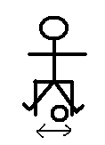

1. Push your walking aid forward, slowly first. When done, pull it backward, slowly. If it goes well try to do it a little bit faster. (Standing or sitting)

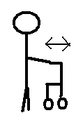

1. Make circles with your shoulders. First try it slowly. Then, when it’s going great, try a little bit faster.
2. Go forward, so you can touch the ground or your knees. Then go back and stand normal but with a stretch back. First try it as slow as possible, and then try it a little bit faster.

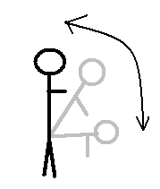

1. Move your back first slowly to the left. Then move your back to the right. When it goes well, try it a little bit faster.

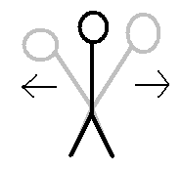

|  |  |  |
| --- | --- | --- |
| Number | How many times? | When? |
| 1 | 5 times right foot  5 times left foot | When you are sitting down.  Before meals, watching tv, etc. |
| 2 | As often as you wish, no need to count | While watching TV |
| 3 | 5 sets of push and pull | See number 1 |
| 4 | 5 times to the front  5 times to the back | See number 2 |
| 5 | As often as you can | When you feel good during the day (not dizzy) |
| 6 | 5 times to the left  5 tim es to the right | See number 5 |